ONEWAY CS BY Temp
/STATISTICS DESCRIPTIVES HOMOGENEITY WELCH
/PLOT MEANS
/MISSING ANALYSIS.

Oneway

Notes
Output Created |  | 05-May-2019 23:52:57
Comments
Input | Active Dataset | DataSet0
Input | Filter | <none>
Input | Weight | <none>
Input | Split File | <none>
Input | N of Rows in Working Data File | 30
Missing Value Handling | Definition of Missing | User-defined missing values are treated as missing.
Missing Value Handling | Cases Used | Statistics for each analysis are based on cases with no missing data for any variable in the analysis.
Syntax |  | ONEWAY CS BY Temp  /STATISTICS DESCRIPTIVES HOMOGENEITY WELCH  /PLOT MEANS  /MISSING ANALYSIS.
Resources | Processor Time | 00 00:00:00.156
Resources | Elapsed Time | 00 00:00:00.158

[DataSet0]

Descriptives
 | N | Mean | Std. Deviation | Std. Error
Between 22°C-18°C | 9 | 38.1111 | 2.84800 | .94933
Between 24°C-26°C | 6 | 38.8333 | 2.85774 | 1.16667
In between 24°C and 22°C | 13 | 38.4615 | 3.47887 | .96487
Less than 18°C | 2 | 38.0000 | 2.82843 | 2.00000
Total | 30 | 38.4000 | 3.00115 | .54793

Descriptives
 | 95% Confidence Interval for Mean |  | Minimum | Maximum
 | Lower Bound | Upper Bound | Minimum | Maximum
Between 22°C-18°C | 35.9219 | 40.3003 | 34.00 | 40.00
Between 24°C-26°C | 35.8343 | 41.8323 | 33.00 | 40.00
In between 24°C and 22°C | 36.3593 | 40.5638 | 28.00 | 40.00
Less than 18°C | 12.5876 | 63.4124 | 36.00 | 40.00
Total | 37.2794 | 39.5206 | 28.00 | 40.00

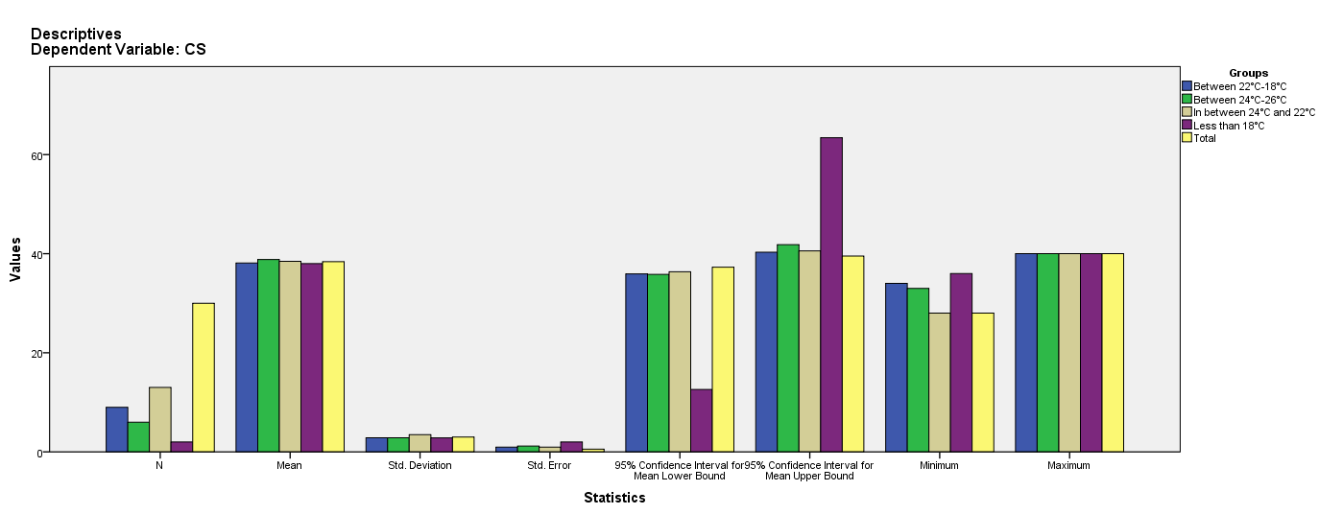

Test of Homogeneity of Variances
CS
Levene Statistic | df1 | df2 | Sig.
.126 | 3 | 26 | .944

ANOVA
CS
 | Sum of Squares | df | Mean Square | F | Sig.
Between Groups | 2.247 | 3 | .749 | .075 | .973
Within Groups | 258.953 | 26 | 9.960
Total | 261.200 | 29

Robust Tests of Equality of Means
CS
 | Statisticª | df1 | df2 | Sig.
Welch | .071 | 3 | 4.737 | .973
a. Asymptotically F distributed.

Means Plots

